**What is a Sales Process?**

* A **sales process** is a **structured set of stages** that a salesperson follows to turn potential customers (prospects) into actual buyers.
* It serves as a **roadmap** for managing relationships, addressing customer needs, overcoming objections, and ultimately **closing sales**.
* A good sales process ensures consistency, efficiency, and customer satisfaction.

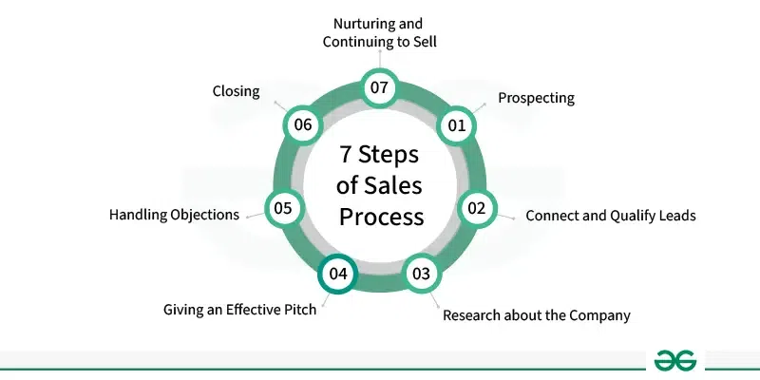

**7 Steps of Sales Process**

**1. Prospecting**

This is the first step in the sales journey where the goal is to **identify potential customers** (known as prospects) who are most likely to benefit from your product or service.

* **How it's done**:
  + Searching through **databases, LinkedIn, social media**, trade shows, referrals, and email campaigns.
  + Using tools like CRM, sales intelligence platforms, or lead generation tools.
* **Goal**: Build a list of potential leads that closely match your **ideal customer profile (ICP)**.
* **Why it matters**: Good prospecting leads to **better-qualified leads**, saving time and improving conversion rates.

**2. Connect and Qualify Leads**

* After identifying potential leads, the next step is to connect with them and qualify them to determine if they meet certain criteria.
* Qualification typically involves assessing the prospect's budget, authority, need, and timeline (BANT) to gauge their level of interest and readiness to buy.
* **Connection**:
  + Make **personalized outreach** via emails, calls, or messages to start a conversation.
  + First impressions matter—focus on **empathy, value**, and **relevance**.
* It prevents wasting time on unqualified leads and allows focus on those **most likely to convert**.

**3. Research About the Company**

* Before pitching, you need to know who you're dealing with. This step is all about **understanding the customer's world**.
* Research includes gathering information about the industry, market position, competitors, recent news or events, and any specific challenges they may be facing.
* This helps you understand their needs better and show that you’re prepared. It also helps you suggest solutions that really fit their situation, which builds trust.
* Deep research allows you to **personalize your pitch** and build **trust and credibility** by showing you care about their specific needs.

**4. Giving an Effective Pitch**

**Goal:** Present your product/service in a way that directly addresses the customer’s problems and adds value.

* **Focus on benefits, not features:** Explain how your product will *improve* their life or business, not just what it does.
* **Use storytelling:** Share success stories or case studies of similar clients to make your pitch more relatable and memorable.
* **Customize your message:** Emphasize parts of your product that match the specific needs of that company.
* **Be engaging and confident:** Use visuals, product demos, or analogies to keep their attention and make a lasting impression.

**5. Handling Objections**

**Goal:** Address any doubts or questions the customer has without losing their interest or trust.

* **Listen carefully:** Let the prospect speak. Don’t interrupt or get defensive when they raise concerns.
* **Acknowledge and empathize:** Show that you understand their worry. For example, "I see why price is a concern...".
* **Provide clear solutions:** Offer detailed answers, comparisons, guarantees, or case studies to eliminate their doubts.
* **Prepare in advance:** Based on experience, be ready with common objections (e.g., price, timing, need) and how to respond effectively.

**6. Closing the Sale**

**Goal:** Finalize the sale by asking for the customer’s commitment to buy.

* **Recognize buying signals:** These include questions about pricing, contract terms, delivery time, or saying “this sounds good.”
* Use closing techniques such as trial closes, assumptive closes, or offering incentives to encourage the prospect to take action.
* Be confident and direct in asking for the sale, but also be prepared to handle any final objections or concerns that may arise.
* Be ready to provide reassurances, give a discount, or answer a last-minute question to seal the deal.

**7. Nurturing and Continuing to Sell**

**Goal:** Build a long-term relationship after the sale to ensure satisfaction, loyalty, and more business.

* **Follow up regularly:** Check in after delivery or onboarding to ensure everything is going smoothly.
* Provide ongoing support, follow-up communication, and excellent customer service to ensure satisfaction and encourage repeat business.
* Look for opportunities to upsell or cross-sell additional products or services based on the customer's evolving needs and preferences.
* **Build trust and loyalty:** Happy customers often become repeat buyers and can refer you to others.

**Geeky Takeaways**

* The **customer’s needs** should guide every step of the sales process.
* While structure is important, **adaptability** is critical because every customer and deal is unique.
* The sales process should be **regularly refined** based on feedback, results, and market changes.

**Advantages:**

1. **Increases Revenue** – Helps businesses make money by selling products or services.
2. **Builds Relationships** – A good sales process strengthens customer trust and loyalty.
3. **Improves Efficiency** – Makes selling easier with organized steps.
4. **Helps Understand Customers** – Businesses learn what people want and need.
5. **Boosts Competitive Edge** – A strong sales strategy makes companies stand out.

**Disadvantages:**

1. **Time-Consuming** – Finding and convincing customers takes effort.
2. **Requires Training** – Sales teams need skills to sell effectively.
3. **Customer Rejections** – Not all customers buy, leading to losses.
4. **Market Changes** – Trends shift, so strategies must adapt.
5. **Can Be Expensive** – Investing in marketing, staff, and tools costs money.

**Applications:**

* **Selling Products & Services** – Businesses use sales strategies to convince people to buy.
* **Building Customer Trust** – Companies focus on relationships so customers return.
* **Using Technology** – Online stores, ads, and calls help reach buyers faster.
* **Understanding Customer Needs** – Sales teams ask questions to offer the right products.
* **Expanding to New Markets** – Businesses adjust sales methods to attract different types of buyers.